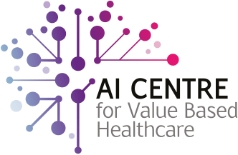
Communications Pack for Fellows in
Clinical Artificial Intelligence
Prepared by The London AI Centre
10 January 2022

Introduction:
Vacancy announcement for the Fellowship in Clinical Artificial Intelligence.
AI Centre website Fellowship announcement and application form: | https://aicentre.co.uk/news-and-events/news/applications-open-fellows-clinical-artificial-intelligence
Short form announcement: | Apply now: Fellowships in Clinical Artificial Intelligence- 1yr post @ 2d/wk, starts May. Open to specialty trainees in London and KSS. HEE supported. Gain expertise deploying state-of-the-art AI in live hospital workflows. Deadline 30 Jan 22. Info: News (aicentre.co.uk)
Long form announcement: | We invite applications for the UK’s first Fellowships in Clinical Artificial Intelligence. The post duration is 1 year at 2 days/wk, beginning in May 2022. It is open to specialty trainees in the London region and Kent Surrey Sussex region. These fellowships are funded and supported by Health Education England. The deadline for applications is 30th January 2022.  Fellows will gain expertise in Clinical Artificial Intelligence (AI) in an integrated pathway alongside their specialty training and implement groundbreaking work in the use of state-of-the-art AI software in live hospital environments.  For more information: News (aicentre.co.uk)
Apply here: | URL link to Fellowship announcement webpage which includes a link to the application form: News (aicentre.co.uk)
Webinar - Info and Q&A: | The London AI Centre will be hosting a webinar for interested applicants.  Date - Wednesday, 19 January 2022  Time - 18.00-18.45 GMT  Interested parties can register to attend here:  https://teams.microsoft.com/registration/FM9wg_MWFky4PHJAcWVDVg,nSYVl_uJU0S1Egym7u47nQ,Rv0ocHkn1Ee2s1c3wVUfDw,SxNBlWS8pkmv527dipZn0w,dvVZDD-s30-UEBVvXE6jxg,o-iIFHY9YkaTKBVdljeE8A?mode=read&tenantId=8370cf14-16f3-4c16-b83c-724071654356  Short link: https://bit.ly/3HHqVdg
Key dates: | Below are key dates pertaining to the Fellowship in Clinical Artificial Intelligence:  10 January 22: Applications open  19 January 22: Q&A Webinar: https://bit.ly/3HHqVdg  30 January 22: Application deadline (23:59)  31 January 22: Shortlisting for interview this week  07 February 22: Remote interviews this week  14 February 22: Successful applicants informed and assigned to trusts this week  May 22: Fellowship begins
AI Centre Contacts: | Use the following contacts if you have any questions regarding the communications information provided above:  Dr. Alexander Deng, Fellow in Clinical Artificial Intelligence, Registrar in Clinical Genetics  email address: alexander.deng@nhs.net  Haris Shuaib, AI Transformation Lead at the London AI Centre, and Head of Clinical Scientific Computing at Guy’s and St Thomas’ NHS Foundation Trust  email address: haris.shuaib@kcl.ac.uk
 | Calling speciality trainees in London and KSS! @AI4VBH are recruiting Fellowships in Clinical Artificial Intelligence, supported by @NHS_HealthEdEng. Gain expertise deploying state-of-the-art AI in live hospital workflows. Deadline 30Jan22. Info: https://bit.ly/3f6xee3m
 | Apply now: @AI4VBH Fellowships in Clinical Artificial Intelligence- 1yr post @ 2d/wk, starts May. Open to specialty trainees in London & KSS. @NHS_HealthEdEng supported. Gain expertise deploying state-of-the-art AI in live hospital workflows. More info: https://bit.ly/3f6xee3
 | If you are a speciality trainee apply now for the first Fellowships in Clinical Artificial Intelligence, working on @AI4VBH #AI platforms. Gain expertise deploying state-of-the-art AI in live hospital workflows. Starts May 22, deadline 30 Jan 22. Info: https://bit.ly/3f6xee3
 | We are pleased to announce the first Fellowships in Clinical Artificial Intelligence, alongside @AI4VBH. Open to specialty trainees in London and KSS, gain expertise deploying state-of-the-art AI in live hospital workflows. Deadline 30 Jan 22. https://bit.ly/3f6xee3
 | 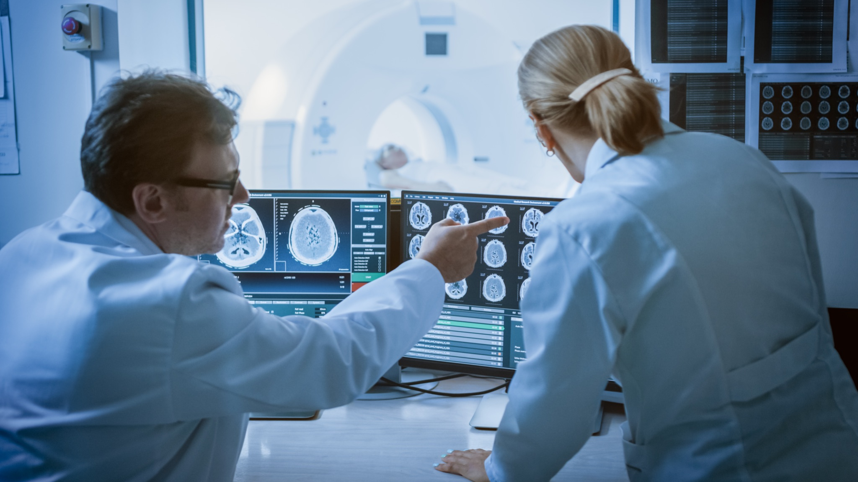
 | 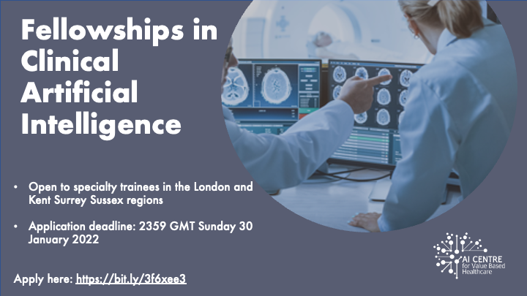
LinkedIn: | https://www.linkedin.com/feed/update/urn:li:activity:6886602783290654720

